**Modern slavery transparency statement**

Cash Access UK helps to sustain communities by providing access to cash and basic banking services for as long as people need them. Through our partners and suppliers, we bring communities access to cash withdrawal facilities, cash and cheque deposit facilities, and face-to-face support and guidance. Our company has a clear purpose and strong values. We have put policies and procedures in place to ensure that the company operates in line with these values.

**Our strategic objectives**

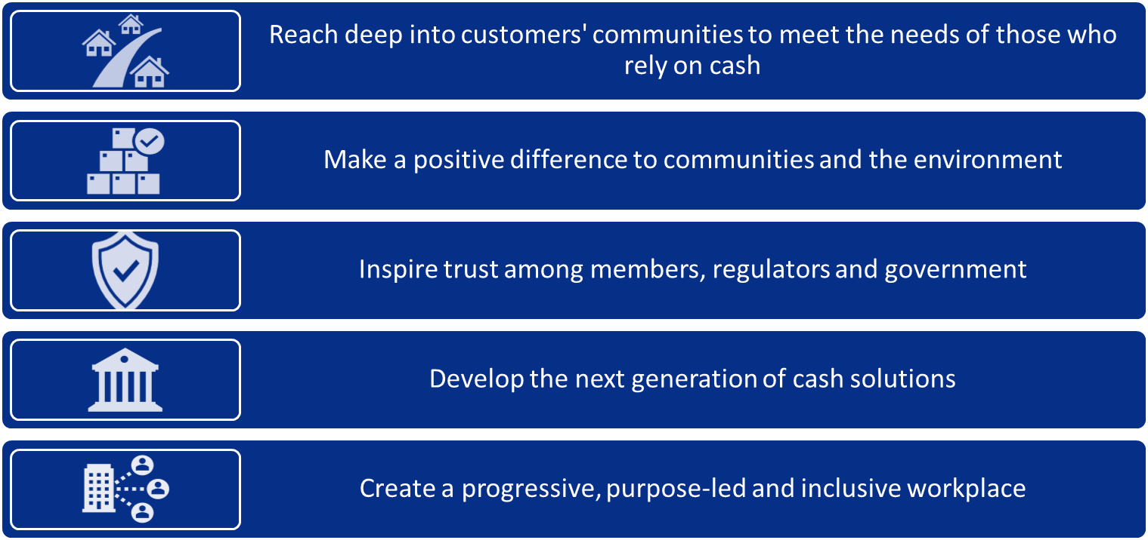

Modern slavery is a crime and a violation of fundamental human rights. We recognise that this takes various forms such as slavery, servitude, forced and compulsory labour and human trafficking. These all have in common the deprivation of a person’s liberty by another to exploit them for personal or commercial gain. Cash Access UK Limited is committed to ensuring:

* that modern slavery and human trafficking have no place in our business or supply chains
* that there is transparency in our business and in our approach to tackling modern slavery throughout our supply chains, consistent with the Modern Slavery Act 2015.

Our [Code of Conduct](https://www.cashaccess.co.uk/media/jy1je2c4/supplier-code-of-conduct.pdf), Procurement Policy and Supplier Management Framework help us to ensure we work with suppliers aligned to our values and makes clear the behaviour they can expect of us and what we expect of them.

Our Environmental, Social and Ethical Policy aligns with our strategic objectives to make a positive difference and increase our reach to support those within our communities who need our support and to create a progressive, purpose-led and inclusive workplace

**Our structure**

Cash Access UK is a not-for-profit company limited by guarantee. This means that rather than shareholders and shares, we have Members. Our Members are the banks who have chosen to come together to protect cash access for their customers. Our Member firms provide all our funding and work closely with us to make sure we are providing the right services to support their customers.

Our Board is responsible for all major decisions about the way the company is run. This includes everything from setting our strategy and agreeing our annual budget to managing risks and helping develop the company's culture. The Board is made up of an independent Chair and two independent directors, five directors nominated by our Member firms, our Chief Executive and Chief Financial Officer. This gives the Board a wide range of perspectives, industry experience and deep insight into how the company is running. The Board meets five times a year.

The day-to-day running of the company is overseen by a senior team of directors who are responsible for the effective operation of the company in line with our objectives, policies, purpose and values, and are accountable to the Board.

**Our values and our people**

Our values ensure that we put the customer first, and that we are inclusive and collaborative. These values guide our culture and the way we work, setting the tone for how colleagues interact with one other and with suppliers, Member firms and other parties.

Cash Access UK has expanded over the last year and we expect to have a workforce of around 80 by the end of 2024, including a small number of colleagues on secondment from UK-based banks. All staff are based in the UK. We seek to treat everyone fairly, consistently and respectfully and our people policies aim to create an environment that is open, transparent and psychologically safe.

We operate robust recruitment processes in line with UK employment law. These include ‘right to work’ document checks and checks to ensure employees are aged over 16. Our pay and reward policy is clear and transparent, and the Chair of our Remuneration Committee has engaged with employees on the Committee’s role and considerations in setting that policy. We also have a whistleblowing policy to enable colleagues to raise any concerns confidentially and safely, including those relating to potential unlawful practices within our supply chains, without fear of reprisal.

**Our supply chain**

While we consider our direct exposure to slavery and human trafficking to be relatively limited, we recognise that our business is exposed to greater risk when dealing with suppliers, particularly those who have operations and suppliers in other countries, or in high-risk industries. Cash Access UK partners with a range of suppliers, all of whom help us deliver our objectives and ensure we serve communities and our Member firms effectively. A significant proportion of our business is outsourced to suppliers.

We inform every supplier and potential supplier of our approach and expectations with regards to slavery and human trafficking. We also:

1. seek confirmation from existing suppliers that they are not aware of any incidents of slavery and/or human trafficking within their own business or supply chain, and that they have policies and procedures in place to mitigate the risks of slavery and human trafficking and to encourage reporting of any incidents that do arise.
2. include specific requirements in supplier contracts and/or confirmation of their compliance to our [Code of Conduct.](https://www.cashaccess.co.uk/media/jy1je2c4/supplier-code-of-conduct.pdf)
3. undertake due diligence on suppliers in accordance with our third-party risk policy.

**Our work in 2023**

During 2023 we developed and embedded our Procurement Policy and Supplier Management Framework to enhance our procedures and controls in ensuring our supply chain is aligned to our values and approach, including in regards to Modern Slavery. We also increased our awareness of modern slavery by training all existing and new employees.

**Our plans for 2024**

In 2023, we had no reported incidents of modern slavery, but we acknowledge that modern slavery is prevalent in society and can be difficult to detect and identify. As such, we will continue to be vigilant to maintain and raise awareness among our colleagues and supply chain during 2024 by continuing to ensure all members of staff are trained on an annual basis and suppliers are identified, managed and onboarded in accordance with our Procurement Policy, Supplier Management Framework and Code of Conduct.

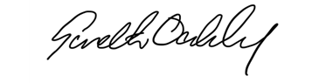

Gareth Oakley  
**Chief Executive**

This statement has been approved by the [Board of Cash Access UK](https://www.cashaccess.co.uk/about-us/board-and-senior-team/) and will be updated and published annually within 6 months of our financial year ending.

**May 2024**