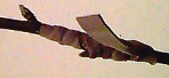

Splice and Bark Grafting

THIS IS A PICTURE STORY OF GRAFTING SHOWING MY STYLE.
BY Gordon C. Nofs

Splice Graft
Figure 1 is a splice on scion and stock. The angular cut being 1" to 1 ½" long. The diameters being as close as possible. I have made these grafts as small as 1/8" dia. Keep cuts flat and clean. "REMEMBER" THIS TIP of MINE! Always try to make your cuts with a bud as close to the ends of both. This way the sap will flow to feed that bud and feed the growth. Take all other buds except a few at the top off this forces all the strength to the area you want. After new growth is eminent, keep "ALL" growth off below the graft.
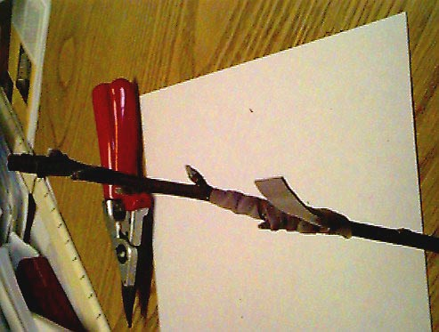
figure 1
Figure 2 is just a closer look.
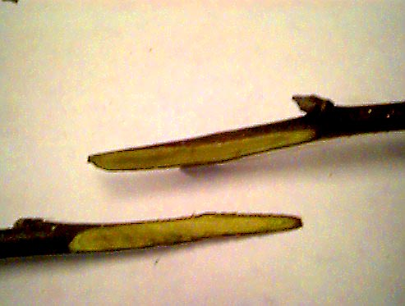
figure 2
Figure 3 is showing the two pieces fit as perfectly together as you can. Wrapped snugly with a .02 X 3/8 X 8" rubber grafting strip. Looped under the last wind. On the smaller grafts like this one I wrapped up and then back down. Then again on some larger type grafts I have used as many as 4 or 5 just to get wrapped once up completely. Each rubber snuggling up the last till it is tied up at the end by putting the end under a loop.
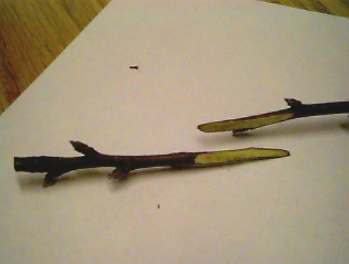
figure 3
REMEMBER: These items were done indoors with the snow flying outdoors for show only. There would normally be growing leaves on the stock that your are putting dormant scions onto.

Bark Graft
Figure 4 is showing a bark graft. The scion can be 1/8" up to ½". The stock must be bigger than the scion. The scion is cut like a splice, but is trimmed up both sides 1/32 to 1/16 to callus much easier in the closeness to the cambium. If the stock is big enough I have put in as many as 4 scion on one stock.
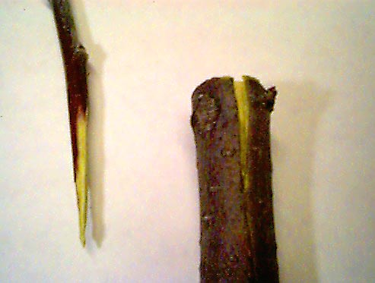
figure 4
Figure 5 shows how the scion is pushed into the slit of the stock. I do two things here to insure tight fit. First I scrape the bark from the 1/8" to ¼" off the tip on the outside. Then I only start the opening enough to start the scion into the slit and the easily push and guide it till it is in as far as the splice has been cut.
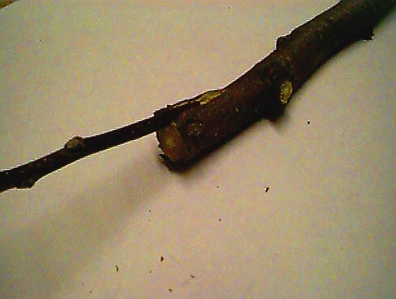
figure 5
Figure 6 is the grafting rubber snugly in place, tightly but not so there is some give tight enough to pull the slit stock to fit against the inserted scion.
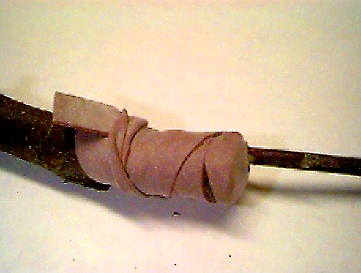
figure 6
Figure 7 is a grafting knife sharpened on one side only . Flat side to be against the scion. Right hand and left hand will be different. Rubber grafting strips .02 X 3/8" X 8". A permanent marker. I use colored electrical tape, available at hardware stores here, to mark date of graft, what is grafted. Date is so that I don't even start to bother them for 2 weeks. Apples sometimes take and leaf then or before. Nuts I don't even bother for 4 weeks. Pecans 6 weeks.
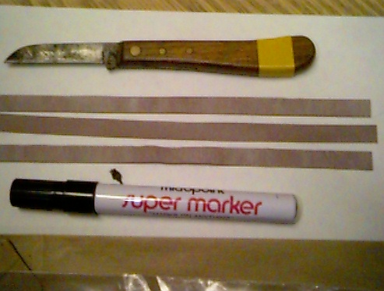
figure 7
Figure 8 shows tape, lunch bag, long 1 quart freezer bag, and my Felco pruner.
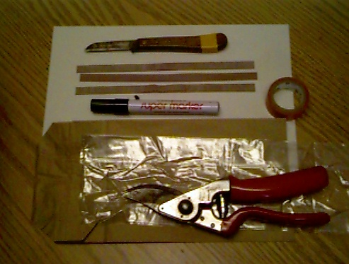
figure 8
Figure 9 Shows a holder of my supplies that I welded up of large juice cans. The plastic bucket handle is held in place with welded fender washers.
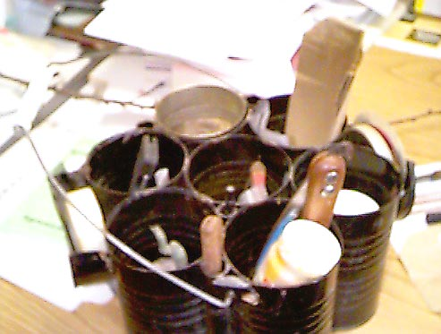
figure 9
Figure 10 is the one quart, long type plastic freezer bag. The dampness included in this bag is made up of a few drops of common household bleach to a half glass or so of water. I usually carry my scions in this glass also. I pour about a ½ teaspoon, more or less into the bag. I then grab the bag at the bottom and with my other hand give a pulling out motion like I was trying to squeeze out that I had just put in. This leaves plenty of moisture that is able to fight mold or fungus. I blow the bag up and put over graft, trying to leave a small space at the top for leaves. Sometimes I have to again give it more air to fill when it is in place. Takes a little practice. Then twisting open end around I tie off with a twist tie. Its own little greenhouse.
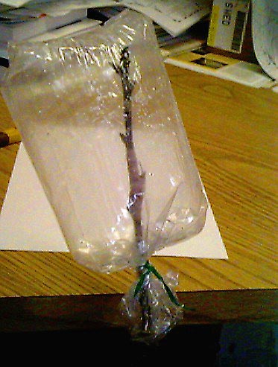
figure 10
Finally in Figure 11 I have taken the paper lunch bag which can be purchased at grocery stores in small packets. I proceed to diagonally cut all the bottom corners about 1 inch. I proceed to place this over the blown up and tied plastic bag.
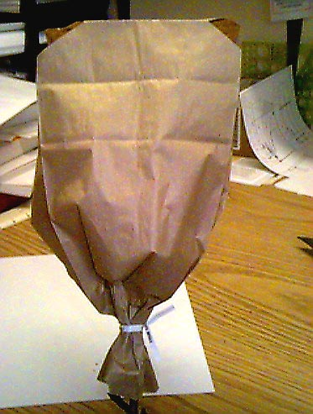
figure 11
The small opening serves to give a little light, and a window to peek in. It also hold the plastic bag in an upright position. If you can not see in to well after 2 weeks, open down a little on a north east corner. Again, apples 1 ½ 2 weeks you can start to check. Nuts mostly 4 weeks except Pecans and filberts 6 weeks.

Gordon C. Nofs
6422 E. Pierson Rd.
Flint, Michigan 48506-2258
Phone (810) 736-7089
Send e-mail to Gordon C. Nofs

Copyright © 2000 Gordon C Nofs.
Page created 30 October 2000. Last updated 30 October 2000 at 5:25 PM.
.

