Construction and utilization of lunar observatories.

Roger Angel

Steward Observatory, University of Arizona

Testimony for the hearing on Lunar Exploration
US Senate Committee on Commerce, Science and Transportation,
November 6th 2003

I am an astronomer at the University of Arizona, where big ground-based telescopes and their mirrors are made. Steward Observatory is now completing the mirrors for the Large Binocular Telescope, which will become the single largest telescope in the world.

In September this year I chaired a meeting sponsored by the National Academy of Science’s Space Studies Board, looking at future needs and technologies for large optics in space. Our group of represented astronomers, Earth scientists and several government agencies who share a common interest in very large telescopes. Optics bigger than the 2.4 m Hubble and the planned 6 m James Webb Space Telescopes would be valuable for astronomical research, for environmental studies and for defense. The different uses lead to different telescope configurations (single dishes, arrays), wavelengths of operation (from ultraviolet to millimeter), and different optimum locations in space. But we found strong common interest across the agencies in developing technologies to make and control very big optical systems to exquisite, diffraction-limited quality and in the infrastructure to construct, deploy and service very large optical systems in space.

Optics for Earth imaging and defense need to be near the Earth, and geosynchronous orbits are especially valuable. For astronomy, operation in low Earth orbit, like Hubble Space Telescope, has the huge, proven advantage of astronaut access, but has limit performance because of the constant cycling in and out of sunlight. The major drawback for low Earth orbits is that deep infrared observations are not possible, because they require a cryogenically cooled telescope, far from the Earth to get away from its radiated heat, and permanently shaded from sunshine. Looking at the future balance of large telescopes on the ground and in space, very cold telescopes in space enable science that is completely impossible from the ground. We see this trend already with the recent successful WMAP and SIRTF telescopes, and the planned James Webb telescope, all cryogenic telescopes operating very far from Earth.

Let me mention two major astronomical goals for a much bigger, ~ 20 m cold telescope in space. One is the search for life on any warm, Earth-sized planets around nearby stars like the sun. We expect these will be found with smaller telescopes, but we have no idea if they will have life. On Earth, abundant life chemically transformed the atmosphere already 2 billion years ago. A big telescope or array could detect such transformations by spectroscopy. Another goal will be to see starlight that has been on its way towards us through most of time. Our understanding is that the big bang created a uniform gas of just hydrogen and helium, and that after this cooled off the universe was completely dark and without form for hundreds of millions of years. Gravity slowly pulled the gas together into lumps until at some point these exploded into the first massive, brilliant stars, and started to make the elements like carbon and oxygen and iron from which the Earth and life are made. We know a lot about the big bang, because it was so bright we can see it easily, now cooled off to become radio waves. First seen from New Jersey, these were recently mapped out from Antarctica and by WMAP. Today we can only speculate about the first stars, but their light will now be in the form of faint heat waves. A very big, very cold telescope in space that stares for a year at the same spot could likely detect them find out when they formed and what they were like.

Big cryogenic telescopes in space present a conundrum. We can see how to build, maintain and improve them, based on experience with the Hubble Space Telescope and in building ISS. But how do we do this if the telescope must be operated far from Earth?

There are free orbits far from Earth, towards or away from the sun, where a spacecraft will stay put and not drift away like SIRTF. Most thinking so far at NASA has focused on operation in the one a million miles beyond Earth, where WMAP was and the Webb telescope is to go. Servicing a big telescope would likely involve ferrying new instruments or even the whole telescope back and forth to a more accessible orbit, but still ¼ million miles away.

The Moon’s south pole is an alternative location. The pole is down in the Shackleton crater where the sun never shines and cryogenic temperatures prevail. If there were a Moon base on the crater’s edge, this would be convenient for construction and maintenance. The Moon has no atmosphere, so light from the stars would have the same pristine quality as in free space. Only the sky’s southern hemisphere would be observable, but this is not a major astronomical limitation.

The lunar south pole is a good place for a lunar base, independent of any telescope. The craters are believed to contain water ice, more valuable than gold for the base¹. Also, because the Moon’s spin axis is not tilted like the Earth’s there are no seasons and the crater rim has small areas of nearly eternal sunshine, simplifying problems of maintaining electric power and temperate living conditions². Furthermore, the area is of intrinsic scientific interest: the adjacent South-Pole-Aitken basin is the oldest and deepest impact crater on the Moon, and has been flagged for study in the recent NRC study³.

Many technical, engineering and infrastructure issues remain to be explored. The Moon provides a platform on which to build big structures, but it also comes with gravity and weight, albeit at 1/6th of the Earth’s value. Freely-orbiting telescopes avoid the need for bearings and drives. On the Moon magnetic levitation on superconducting bearings might simplify the task of turning the telescope around during each month to track the stars. We would need to make sure the telescope optics were not spoiled by vibrations or dust and condensed gas from the base.

Gravity could be turned to an advantage for a special telescope to look back to the very faint first stars, which will be all over the sky. From the Moon’s pole the infrared sky is darkest overhead, and we can look there uninterrupted at the same unchanging patch of sky for the years needed for the study. Thus a specialized telescope for this work could be fixed in place looking straight up. If desired, very high resolution images of the same patch could be made with multiple such telescopes laid out as an interferometer, again with no big moving parts. We may even be able to use a trick to make a telescope mirror looking straight up by spinning a thin layer of reflecting liquid in a big dish. A 6-m diameter telescope of very high quality has been built like this very inexpensively in Canada⁴. No matter the exact shape of the bowl, the liquid surface takes the shape of a perfect telescope mirror. Bigger diameters can’t be used on the Earth because the spinning makes a wind that ruffles the surface. But with no wind or air on the Moon, a 20 m or larger mirror might be made simply this way. A cryogenic liquid with evaporated gold coating would be used.

More details of zenith-pointing telescopes and their scientific potential are give in the attached white paper. While it would do some jobs really well, a fixed telescope would not satisfy the many astronomical goals which need access over a good part of the sky. For example, the few nearby stars where we can hope to study Earth-like planets are randomly distributed all over the sky. But it could do great science and give a basis of experience at the base for building a fully-steerable big telescope.

Image taken from the surface of the Moon by astronauts John Young and Charles Duke, showing the Large Magellanic Cloud and nearby sky in far ultraviolet light⁵. The circle shows the 6° diameter field accessible to the zenith pointing telescope at the lunar south pole.

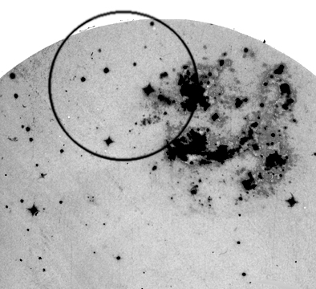
In conclusion, based on astronomical goals and telescope engineering constraints, the lunar pole deserves to be taken seriously as an observatory site for large cryogenic telescopes, along with remote free orbits. I hope that both options will be evaluated in considering the future of human spaceflight beyond near-Earth orbit.

References
1. Vondrak, R. R. and Crider, D. H. Ice at the Lunar Poles. American Scientist (2003)

2. Bussey, D. B. J., Robinson, M. S., Spudis, P. D. Illumination Conditions at the Lunar Poles 30th Annual Lunar and Planetary Science Conference, Houston (1999)

4. Cabanac, R. A., Hickson, P. and de Lapparent, V. The Large Zenith Telescope Survey: A Deep Survey Using a 6-m Liquid Mirror Telescope in A New Era in Cosmology, eds Metcalfe, N. and Shanks, T. ASP Conference Proceedings 283. p 129 (2002)

3. NRC New Frontiers in the Solar System: An Integrated Exploration Strategy. Space Studies Board (2002)

5. Page, T and Carruthers, G. R. Distribution of hot stars and hydrogen in the Large Magellanic Cloud. Ap. J. 248, 906-924 (1981)

Attachment

A deep field infrared observatory at the lunar south pole

White Paper for the Space Studies Board (SSB) and the Aeronautics and Space Engineering Board workshop on "Large Optics in Space”

Roger Angel

Steward Observatory, University of Arizona
September 6, 2003

Abstract

Our understanding of the early universe has been revolutionized by deep optical fields imaged with the Hubble Space Telescope (HST) and analyzed spectroscopically with larger ground-based telescopes. Much deeper fields in the infrared could reach still further back in time, to the era of first star formation at redshift z~25. But spectroscopy will require very long integrations with a very large cryogenic telescope located above the atmosphere.

The Moon is an ideal location for such a telescope. Provided the field is chosen near the south ecliptic pole, it could be viewed continuously by a fixed, cryogenic, zenith-pointing telescope or interferometer at the lunar south pole. The unique advantage of the Moon is its combination of gravity and no atmosphere. A zenith pointing mirror can be made simply by spinning a cryogenic liquid and (vacuum) coating it with metal. The pole is a practical location because there is nearly-continuous sunshine for solar power, yet cryogenic cooling requires only simple shielding. There is also water ice in the permanently dark craters. Given a manned polar base, telescopes with primary mirrors as large as 20 m and with exquisite, diffraction-limited accuracy could be constructed. With auxiliary beam-steering optics, a continuous observation of the ecliptic pole could be maintained for years. It would have 3 times higher resolution and reach 100 times fainter than the James Webb Space Telescope (JWST).

Rationale
The 6-m JWST will obtain the first deep images of the high redshift universe, taking advantage of the very low zodiacal sky background in the 2-5 μm spectral region. But even much larger future ground telescopes will be incapable of spectroscopic follow up, because of thermal emission and absorption by the atmosphere and telescope. Larger telescopes in space will be necessary, cryogenically cooled and used with spatially-multiplexed spectrometers in very long integrations. As an example, spectra of the first stars formed at very high redshift may take a few years to record, even with much larger aperture than JWST.

If a cryogenic telescope is required to point at different targets around the sky, the best location is a gravity-free environment far from the warm Earth, such as L2. It would be difficult, though, to operate and maintain to diffraction-limited accuracy a 20 m telescope a million miles from earth. But for a telescope to be dedicated to deep field spectroscopy, access to the whole sky is not necessary. A single extragalactic field chosen near one of the ecliptic poles, where the infrared sky is darkest, is sufficient.

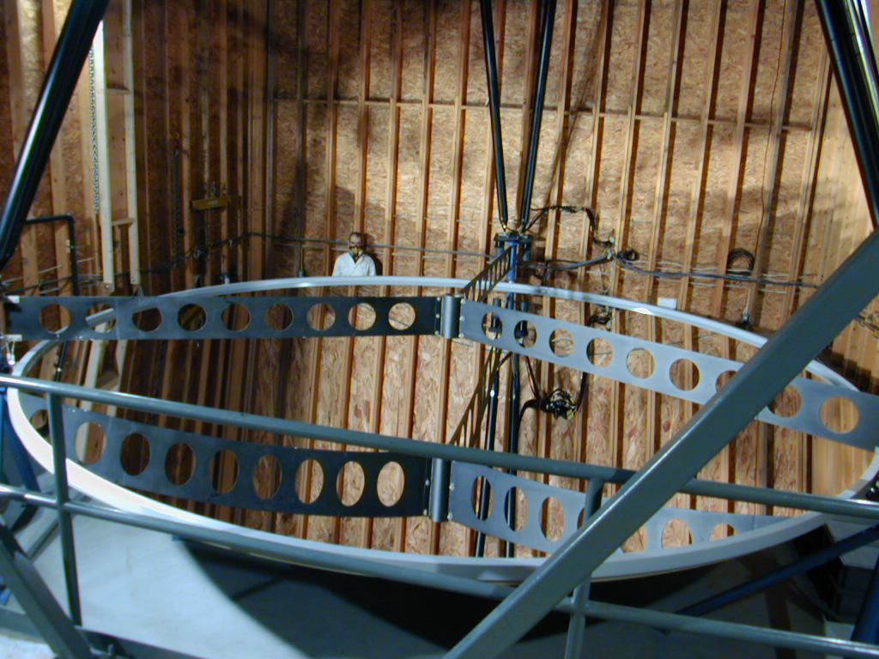
For such a task, the lunar south pole is a location closer to home with unique advantages. Here the south ecliptic pole lies very close to the zenith, because the Moon’s spin axis is tilted only 1.5 degress to ecliptic pole. The precession period is 18 years. Cryogenic operating temperature needed for infrared observations can be obtained by locating the telescope in a permanently dark crater. Alternatively, a simple perimeter radiation shield would suffice, because the sun and Earth are always close to the horizon. To track the monthly rotation of the field, only the instrument and small auxiliary optics need be moved.
Figure 1. 6 m diameter mercury liquid mirror telescope (courtesy P. Hickson)

A liquid mirror primary mirror telescope
Zenith-pointing telescope mirrors of liquid mercury have been made up to 6-m diameter, spinning at a few revolutions per minute in the 1-g gravity field of Earth (Cabanac, Hickson and de Lapparent, 2002). The dish holding the liquid is made of stiff, lightweight composite panels, shaped to within a fraction of a millimeter of the final figure. The liquid when spinning at the correct speed is only 1 mm deep. The existing telescopes are at mid-latitudes, and include compensation for field motion at near the sidereal rate of 15 arcsec/second. They also have to deal with vibrations and wind acting directly on the liquid surface. Despite these difficulties, images of better than 1 arcsec are obtained.

The south-pole lunar environment is much more favorable for liquid mirror telescopes. There is no wind and very little seismic disturbance. A 20 m diameter f/1 mirror would require rotation at 2 rpm. The bearing might use cryogenic, superconducting magnetic levitation to ensure freedom from vibration. A tripod would be erected above the mirror to support secondary and beam-steering optics. The slow monthly rotation of the south ecliptic pole field on the sky (15 milliarcsec/sec) would be compensated by rotation of the instrument and corrector optics. Mercury is not suitable for a cryogenic telescope as it freezes at 234K. Dimensional changes on freezing and cooling would spoil the accurate figure of the liquid phase. What is needed is a cryogenic liquid of very low vapor pressure, to avoid evaporation loss over years of operation. An example is 1-butene, which is liquid at 90K with a vapor pressure of 10⁻⁷ torr. To obtain high reflectivity, after reaching equilibrium in the rotating dish the liquid (which is quite viscous when cold) would be coated like a glass mirror with evaporated metal layer. Given a low emissivity coating (1% in the thermal infrared), a telescope at 90 K will reach the zodiacal background at wavelengths shorter than 8 μm.

Sensitivity and scientific potential
For imaging in the 0.8-8 μm spectral range, sensitivity is limited by photon noise in the optical and thermal zodiacal light. The scaling is as D²/√t where D is telescope diameter and t is integration time. Sensitivities are listed for the JWST with D=6 m and t=100,000 sec or 1.16 days (http://www.stsci.edu/jwst/science/sensitivity/). For the lunar telescope with D=20 m and t = 100 days, the improvement will be by a factor 100. The 10σ point source sensitivity in the range 1-4 μm will then be ~ 1.5x10⁻¹¹ Jy, and from 5-8 μm about 3x10⁻¹⁰ Jy.

For spectroscopy at resolution 1000, we envisage an integration of 1000 days. If the sensitivity is set by detector noise, as it is for JWST, the sensitivity again scales as D²/√t for a factor of 300 improvement, and we find 10σ limits of 5x10⁻¹⁰ Jy from 1-4 μm, and 6x10⁻⁹ Jy from 5-8 μm. The scientific potential of observations to this limit is explored in the Appendix by Dan Eisenstein and Betsy Gillespie.

The field at the south ecliptic pole.
The telescope corrector gives access to fields up to 1.5° off–zenith. This would allow for observation of the south ecliptic pole at any time, and for observations of objects up to 3° from the pole, in a direction depending on the Moon’s 18 year precession.

Figure 2 shows the accessible field circled. The Large Magellanic cloud (LMC) is to the right. This historical ultraviolet image was recorded on the Moon over 30 years ago, by Apollo 16 astronauts John Young and Charles Duke. (Page and Carruthers, 1981) The ecliptic pole at the center of the circle is clear of absorbing dust in the LMC (E_{B-V}=0.05).
Figure 2. The circle shows the 6° diameter field accessible to the lunar zenith pointing telescope. Ultraviolet image recorded on the Moon by John Young and Charles Duke.

Because of the low zodiacal background at the ecliptic poles, they may become already the most deeply observed regions of the infrared sky by the time detailed observing plans are developed for the lunar facility. Already deep near infrared sky surveys of the poles are planned for the SNAP telescope.

Logistical support at the lunar south pole.
A liquid mirror telescope requires assembly of the dish and bearing, a tower to support the secondary and auxiliary optics, filling with liquid and spinning up, and vacuum coating. These steps might be difficult to automate or conduct robotically, but would seem to be well suited as a task for astronauts operating from a Moon base. In fact, the south pole is a leading candidate site for such a base, because of the availability of nearly continuous sunshine for solar power (Bussey et al, 1999) and the likely presence of water ice in the dark craters (Vondrak and Crider, 2003). It is also a place of intrinsic geological interest, the South Pole-Aitken basin region being the the oldest and deepest impact crater preserved on the Moon (NRC, 2002)

Precursors and evolutionary developments
While the principles are well understood, much development will be needed to reach the 20 m spinning mirror target. As a first step, a remotely deployed cryogenic 1 m telescope might be deployed on the rim of the Shackleton crater. Once a manned base is established, construction techniques could be tested by erection first on the Moon a smaller scale spinning mirror prototype, for example one of the current 6 m diameter.

Once a single 20 m dish was in operation, a still more powerful observatory could be created by addition of duplicate 20 m elements, linked interferometrically. The same field at the zenith is ideally located for interferometric study, because the baseline linking the elements is turned by the Moon’s rotation about the line of sight. The requirements for path correcting elements in the interferometric link are minimal, and interferometric imaging by the Fizeau method will be possible over a wide field of view (Angel, 2002).

References
Angel, J. R. P. Sensitivity of optical interferometers with coherent image combination Proc SPIE 4838, (2002)

Bussey, D. B. J., Robinson, M. S., Spudis, P. D. Illumination Conditions at the Lunar Poles 30th Annual Lunar and Planetary Science Conference, Houston (1999)

Cabanac, R. A., Hickson, P. and de Lapparent, V. The Large Zenith Telescope Survey: A Deep Survey Using a 6-m Liquid Mirror Telescope in A New Era in Cosmology, eds Metcalfe, N. and Shanks, T. ASP Conference Proceedings 283. p 129 (2002)

NRC New Frontiers in the Solar System: An Integrated Exploration Strategy. Space Studies Board (2002)

Page, T and Carruthers, G. R. Distribution of hot stars and hydrogen in the Large Magellanic Cloud. Ap. J. 248, 906-924 (1981)

Vondrak, R. R. and Crider, D. H. Ice at the Lunar Poles. American Scientist (2003)

Appendix

Notes on Ultra-deep field science from Dan Eisenstein and Betsy Gillespie

Current speculation is that the first stars were very massive (100 to 1000 solar masses). Such stars have temperatures around 100,000 degrees and radiate at the Eddington limit (10⁴⁰--10⁴¹ erg/s). This means that about 90% of the energy is emitted in photons hard
enough to ionize hydrogen and helium. For example, we would predict the Lyman alpha flux to be about 1 nJy at z=25 and R=1000 for a 100 M star. The result would scale linearly with the star's mass. The equivalent photons for helium can't pass through the IGM, so the best helium line is the HeII line at 1640 A, which would have a flux
about 10% of the Lyman alpha line (i.e. 0.1 nJy for the above example).
Unfortunately, it is unclear whether Lyman alpha photons from the regions around these massive stars can propagate through the neutral IGM that surrounds these first stars. If not, then the Lyman alpha photons are rescattered into a very low surface brightness sphere about 10'' across.
H is not rescattered and is similarly bright, about 1 nJy in our example. However, these photons must be observed at 15m where the backgrounds are much less favorable. Note that both the HeII line and H are intrinsically thin, so one might benefit from going to higher resolution than R=1000.
The continuum itself from the first stars are very faint: about 0.0002 nJy per 100 solar masses at z=25.
So, our conclusion is that a single first star is detectable only through line emission and that the brightest line, Lyman , has sufficient flux but may be rescattered by the IGM. HeII and H remain interesting, particularly if the star or star cluster is 1000 M rather than 100.
At z=10, the sensitivity to His fantastic. 10⁴⁰ erg/s of line emission yields about 20 nJy of flux, which is easily detected. In the local universe, that corresponds about 0.01 solar mass per year of star formation; at high redshift and hence lower metallicity, the detectable star formation rate would be more like 0.001 solar mass per year. One sees all manners of galaxy and star cluster formation at z=10.
One class of known objects that would be particularly interesting to see in formation is globular clusters. Local evidence suggests that globulars must form very quickly, less than 10 Myr. An instantaneous burst at z=25 of 10⁵ solar masses with a normal IMF would be detected in the continuum 10 Myr after the burst at 0.015 nJy (10) at 3.5m.
In other words, one can detect young globular clusters in the continuum at any relevant redshift. At z=10, one could likely get spectroscopic detections of the more massive and young cases. In the local universe, globular cluster formation is associated with large mergers; globulars could be an interesting tracer of hierarchical galaxy formation.
First supernovae are much brighter than first stars and are detectable even at z=25 with this telescope. Indeed, the predictions are that supernovae from very massive stars at z=20 are quite bright, m=26, and so will be detected by JWST. With this telescope you would get spectroscopic time-series. More conventional supernovae, i.e. from normal stars, should also be visible.
As a speculative matter, if the neutral IGM does rescatter the earliest Lyman alpha photons, these photons may still be detectable. The action of the IGM is to blur the emission onto scales of 10'' and 1000 km/s. However, these regions contain only about 10⁹ solar masses and so the emission will be highly clumped on these scales. This means that the background, when viewed on 10'' and 1000 km/s scales, will be highly variable. If 0.1% of all stars form as very massive stars at high redshift, then the mean intensity today from this smeared background of Lyman  photons is about 2% of the total extragalactic near-infrared background. The high redshift portion amounts to about 12 nJy per square arcsecond, which is certainly detectable with the lunar telescope. The problem is distinguishing that emission from the other 98% of the background. However, the bulk of that emission is in relatively compact sources (i.e. faint galaxies). By looking between the galaxies and by seeking small-scale variations in the spectral dimension (e.g. by using the known redshifts of the galactic cores to model the intergalactic spectra), one might be able to isolate these earliest objects as low surface brightness narrow-band features. This would require the full data cube and excellent systematic control, but it may be feasible.
Please keep in mind that this last idea is not conventional wisdom; I'm not even sure it's appeared in the literature!
After the universe is reionized, the intergalactic medium begins to recombine. This is a very low surface-brightness emission process. The intensity is 0.013 nJy per square arcsec times ((1+z)/20)^{1.5} ², where Delta is the density of the gas relative to the cosmic mean. For a 1 sq arcsec patch, one could detect Delta's as low as 30. That's not quite the cosmic web at =5, but it is still impressive. One would be making maps of the mid-density gas and correlating it with the star formation of protogalaxies. Note that the flux levels are similar to the IR background arguments in the last section, so one would still likely be having to model the foreground galaxies to remove their faint wings.

