Cecilia Capetti, Giulia Vendemiati
Methotrexate efficacy in Rheumatoid arthritis - Genetic polymorphisms implicated in keyMTX pathway genes.

Rheumatoid arthritis (RA) is a chronic inflammatory disease of unknown etiology marked by a symmetric peripheral polyarthritis. It is the most common form of chronic inflammatory arthritis and often results in joints, tendons and bursae damage and physical disability.
The incidence increases between 25 and 55 years of age, after which it plateaus until the age of 75 and then decreases.
Like many other autoimmune diseases, RA occour more commonly in females compared to males. Given this preponderance of females, various theories have been proposed to explain the possible role of estrogens in enhancing the immune response: some experimental studies have shown that estrogen can stimulate production of tumor necrosis factor alpha (TNF-alpha), a major cytokine in the pathogenesis of RA.
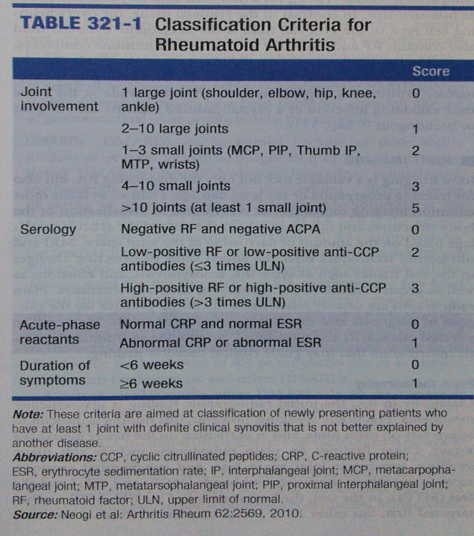
Complains are early morning stiffness lasting more than 1 hour involving the small joints of hands and feet, usually in a symmetric distribution (wrist, metacarpophalangeal and proximal interphalangeal joints)(Fig.1). Moreover, because it is a systemic disease, RA may result in a variety of extraarticular manifestations, including fatigue, subcutaneous nodules, lung involvement, pericarditis, peripheral neuropathy, vasculitis and hematologic abnormalities.
Insights gained by a wealth of basic of clinical research over the past 2 decades have revolutionized the contemporary paradigms of diagnosis and management of RA. The science of RA has taken a major leap forward with identification of new disease-related genes and further deciphering of the molecular pathways of disease pathogenesis. The relative importance of these different mechanisms has been highlighted by the observed benefits of the new class of highly targeted biologic therapies. Despite these gains, incomplete understanding of the initiating pathogenic pathways of RA remains a sizable barrier to its cure and prevention. The historic descriptions of crippling arthritis are currently encountered much less frequently. Much of this progress can be traced to the expanded therapeutic armamentarium and the adoption of early treatment intervention. The shift in treatment strategy dictates a new mind-set for primary care practitioners – namely, one that demands early referral of patients with inflammatory arthritis to a rheumatologist for prompt diagnosis and initiation of therapy. Only then patients will achieve their best outcomes.
 Fig. 1
TREATMENT OF RHEUMATOID ARTHRITIS
Several developments during the past 2 decades have changed the therapeutic landscape in RA: they include (1) the emergence of Methotrexate as the disease-modyfing antirheumatic drug (DMARD) of first choice for the treatment of early RA, (2) the biological drug that can be used alone or in combination with methotrexate, and (3) the proven superiority of combination DMARD regimens over methotrexate alone, (4) nonsteroidal ani-inflammatory drugs (NSAIDs), (5) glucocorticoids. The disease entails in most cases the use of a combination DMARD regimen that may vary in its components over the treatment course depending on fluctuations in disease activity and emergence of drug-related toxicities and comorbidities.
Harrison's Principles of Internal Medicine, 18e. Longo, Fauci, Kasper, Hauser, Jameson, Loscalzo. (2008)

…FOCUSING ON METHOTREXATE (MTX)
MTX is the DMARD of choice for the treatment of RA and is the anchor drug for most combination therapies; it is also the benchmark for the efficacy and safety of new disease-modyfing therapies. At the dosages used for the treatment or RA, MTX has been shown to stimulate adenosine release from cells, producing an anti-inflammatory effect.
MTX is an antimetabolite belonging to the class of folic acid analogs . Folic acid is an essential dietary factor that is converted by enzymatic reduction to a series of tetrahydrofolate (FH4) cofactors that provide methyl groups for the synthesis of precursors of DNA (thymidylate and purines) and RNA (purines). Interference with FH4 metabolism reduces the cellular capacity for one-carbon transfer and the necessary methylation reactions in the synthesis of purine ribonucleotides and thymidine monophosphate (TMP), thereby inhibiting DNA replication.
Mechanism of action. The primary target of MTX is the enzyme DHFR. To function as a cofactor in 1-carbon transfer reactions, folate must be reduced by DHFR to FH4. Inhibitors such as MTX, with high affinity for DHFR (Ki 0.01-0.2 nM), cause partial depletion of the FH4 cofactors (5-10 methylene tetrahydrofolic acid and N-10 formyl tetrahydrofolic acid) required for the synthesis of thymidylate and purines. In addiction, MTX, like cellular folates, undergoes convertion to a series of polyglutamates ( MTX-PGs) in both normal and tumor cells. This MTX-PGs constitute an intracellular storage form of folates and folate analogs and dramatically increase inhibitory potency of the analog for additional sites, including Thymidylate Synthase (TS) and 2 early enzymes in the purine biosynthetic pathway. The dihydrofolic acid polyglutamates that accumulate in cells behind the blocked DHFR reaction also act as inhibitors of TS and other enzymes.
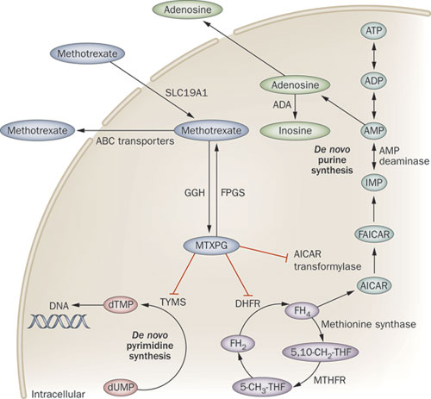Fig. 2
ADME. MTX is readily absorbed from the GI tract at doses of < 25 mg/m2; larger doses are absorbed incompletely and are routinely administered intravenously. The rapid distribution phase is followed by a second phase, which reflects renal clearance (t ½ of 2-3 h). A third phase has a t1/2 of 8-10 h. This terminal phase of disappearance, if unduly prolonged by renal failure, may be responsible for major toxic effects of the drug on the marrow, GI epithelium, and skin. Approximately 50% of MTX binds to plasma proteins and may be displaced from plasma albumin by myriad agents (e.g. sulfonamides, salicylates, tetracyclines, phenytoin). Up to 90% of a given dose is excreted unchanged in the urine, mostly within the first 8-12 h. Metabolism of MTX usually is minimal. After high doses, however, metabolites are readily detectable; these include 7-hydroxy-MTX, which is potentially nephrotoxic. Renal excretion of MTX occurs through a combination of glomerular filtration and active tubular secretion . In patients with renal insufficiency, the dose should be adjusted in a proportion to decrease in renal function, and high dosed regimens should be avoided. When high doses of MTX are given cytotoxic concentrations of MTX reach the CNS. MTX is retained in the form of polyglutamates for long periods.
Pharmacogenetics may influence the response to antifolates and their toxicity. The C677T substitution in methylenetetrahydrofolate reductase reduces the activity of the enzyme that generates methylenetetrahydrofolate, the cofactor for TS, and thereby increases MTX toxicity. The presence of this polymorphism in leukemic cells confers increased sensitivity to MTX and might also modulate the toxicity and therapeutic effect of Pemetrexed, a predominant TS inhibitor. Likewise, polymorphisms in the promoter region of TS affect its expression, and by altering the intracellular levels of TS, modulate the response and toxicity of both antifolates and fluoropyrimidines.
The Goodman and Gilman Manual of Pharmacology and Therapeutics. Ed: McGraw-Hill 2014

Although 70% of patients respond to MTX, treatment may be limited by toxicity. Furthermore, nonresponders require additional disease-modifying antirheumatic drugs (DMARDs) or costly biologic therapies. At present, prediction of those who will not respond to MTX and will require other therapy is not possible.
As delay of appropriate treatment has been shown to result in more joint destruction and lower likelihood of remission , identifying factors that influence MTX response is of great importance.

The factors that are possibly influencing disease course and therapeutic outcome can be classified into (1) clinicopathological variables, which can be divided into patient-related variables (age, gender, ethnicity, and comorbidities), disease-related variables (duration, activity, disability, and biomarkers), and treatment-related variables (compliance, dose, and previous drugs used) [3–9], and (2) genetic factors, such as genetic polymorphisms implicated in keyMTX pathway genes [2, 10–15].
J. W. van der Heijden, B. A. C. Dijkmans, R. J. Scheper, and G. Jansen, “Drug Insight: resistance to methotrexate and other disease-modifying antirheumatic drugs—from bench to bedside,” Nature Clinical Practice Rheumatology, vol. 3, no. 1, pp. 26–34, 2007
http://www-ncbi-nlm-nih-gov.offcampus.dam.unito.it/pubmed/?term=Drug+Insight%3A+resistance+to+methotrexate+and+other+disease-modifying+antirheumatic+drugs%E2%80%94from+bench+to+bedside
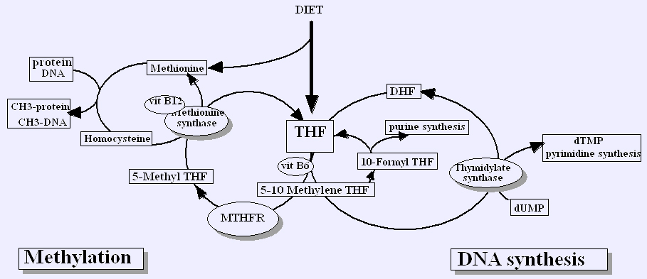Fig. 3
Methylenetetra- hydrofolate reductase (MTHFR), an enzyme involved in folate pathway, is responsible for the conversion of 5,10-methylenetetrahydrofolate (5,10-MTHF) to 5-methyltetrahydrofolate (5-MTHF) that acts as a carbon donor for the remethylation of homocysteine into methionine. On the other hand, methionine can be transformed into S-adenosyl methionine (SAM) and then to S-adenosyl homocysteine (SAH), which can be reversibly hydrolyzed into adenosine and homocysteine. Despite the fact that MTHFR is not directly inhibited by MTX or by its polyglutamated forms (MTXPG), its expression levels seem to influence MTX effect by modifying the folate status.
A.E. vanEde, R. F. Laan,H. J.Blom, R. A. DeAbreu, andL.B.A.Van de Putte, “Methotrexate in rheumatoid arthritis: an update with focus on mechanisms involved in toxicity,” Seminars in Arthritis and Rheumatism, vol. 27, no. 5, pp. 277–292, 1998. [22]
http://www-ncbi-nlm-nih-gov.offcampus.dam.unito.it/pubmed/?term=Methotrexate+in+rheumatoid+arthritis%3A+an+update+with+focus+on+mechanisms+involved+in+toxicity
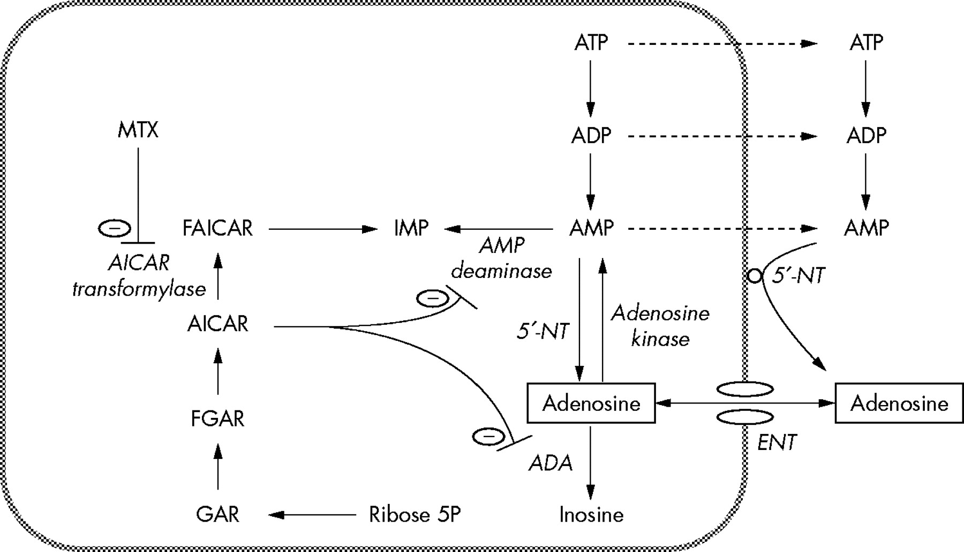Fig. 4
Additionally, it is known that aminoimidazole carboxamide adenosine ribonucleotide (AICAR) transformylase (ATIC), an enzyme involved in the de novo purine synthesis pathway responsible for the conversion of AICAR into formyl-AICAR (FAICAR), is directly inhibited by MTXPG, causing intracellular accumulation of AICAR [16]. AICAR and its metabolites can then inhibit two enzymes, adenosine deaminase (ADA) and adenosinemonophosphate deaminase 1 (AMPD1), which are involved in adenosine metabolism, thus leading to increased intracellular concentrations of adenosine and its consequent release to the extracellular space.This release contributes to the anti-inflammatory effects of MTX since adenosine is a potent anti-inflammatory agent.
Several studies have demonstrated that the occurrence of variations on clinical response to MTX could be explained by genetic polymorphisms in MTHFR and ATIC genes [11, 13–16, 24–28].
J. A. M. Wessels, J. K. de Vries-Bouwstra, B. T. Heijmans et al., “Efficacy and toxicity of methotrexate in early rheumatoid arthritis are associated with single-nucleotide polymorphisms in genes coding for folate pathway enzymes,” Arthritis & Rheumatism, vol. 54, no. 4, pp. 1087–1095, 2006.
http://www-ncbi-nlm-nih-gov.offcampus.dam.unito.it/pubmed/?term=Efficacy+and+toxicity+of+methotrexate+in+early+rheumatoid+arthritis+are+associated+with+single-nucleotide+polymorphisms+in+genes+coding+for+folate+pathway+enzymesThe most studied polymorphism in MTHFR is C677T (rs1801133), which is responsible for a substitution of an alanine to a valine, leading to a thermolabile form of MTHFR with reduced activity [29]. In fact, it has been suggested that MTHFR 677T allele is related to MTX nonresponse.
Similar to MTHFR, some authors have studied the role of the T675C (rs4673993) polymorphism in ATIC, of which the ATIC 675C allele has been associated with improved clinical status and, consequently, with clinical response to MTX.
Y. C. Lee, J. Cui, K. H. Costenbader, N. A. Shadick, M.E. Weinblatt, and E. W. Karlson, “Investigation of candidate polymorphisms and disease activity in rheumatoid arthritis patients onmethotrexate,” Rheumatology, vol. 48,no. 6, pp. 613–617, 2009.
http://www-ncbi-nlm-nih-gov.offcampus.dam.unito.it/pubmed/19193698
MTHFR C677T polymorphism can be genotyped by polymerase chain reaction-restriction fragment length polymorphism (PCR-RFLP) techniques (Restriction fragment lenth polymorphism). Individuals with the CC genotype presente 1 fragment with 198 base pairs (bp), whereas individuals with the TT genotype presente 1 fragment with 175 bp.
ATIC T675C polymorphism can be genotyped using Taq-Man SNP Genotyping Assay (C 362264 10) from Applied Biosystems with fluorogenic binding probes. Allelic discrimination is performed by measuring endpoint fluorescence.
Although MTHFR is not directly inhibited by MTX or MTXPG, its expression levels may play an important role in MTX overall effect by modifying the folate status of the cell. Literature describes MTHFR 677TT as responsible for a reduction of MTHFR activity, leading to reduced 5-MTHF and other folate cofactors levels and, consequently, to decreased adenosine release, which can partially explain MTX nonresponse.
Regarding ATIC T675C polymorphism, ATIC 675T carriers presente an increased risk for nonresponse to MTX. To the best of our knowledge, there are no functional studies reporting the effect of this polymorphism in ATIC activity. Nevertheless, it can be hypothesized that the presence of ATIC 675T allele will lead to MTX nonresponse due to the increased conversion of AICAR to FAICAR (Fig. 4), causing adenosine degradation and its nonrelease, hindering MTX anti-inflammatory effects. Additionally, ATIC 675T allele seems to contribute to the decrease of MTX antiproliferative effect. Moreover, this polymorphism seems to be in linkage disequilibrium with ATIC C347G (rs2372536), of which ATIC 347G carriers (minor allele) have been reported as related to better response. Hence, results report an association between ATIC 675CC (minor allele) and clinical response to MTX.
T homozygosity for MTHFR C677T, and T allele carrying for ATIC T675C can be possible predictive factors of nonresponse to MTX. Thus, the inclusion of these polymorphisms in combination with clinicopathological variables may add valuable information that may help to identify patients who will benefit from MTX treatment and assist clinicians to make better treatment decisions.
Prediction of Methotrexate Clinical Response in Portuguese Rheumatoid Arthritis Patients: Implication of MTHFR rs1801133 and ATIC rs4673993 Polymorphisms (2014)
http://www.ncbi.nlm.nih.gov/pubmed/24967362Reviews on emergent RA pharmacogenetics and meta-analyses of gene association screens for RA risk variants have been recently published. Kung et al analysis examines the association of the RFC1 80GA variant (Arg27His, rs1051266) of the reduced folate carrier 1 gene (also known as solute carrier family 19 member 1) with the efficacy and toxicity of MTX in patients with RA.
RFC-1 is a constitutively expressed folate transport protein that has high affinity for MTX and is involved in transport of folate and MTX into the cell. The RFC1 80GA maps within exon 2 of the gene on chromosome 21 and encodes a substitution of histidine for the arginine at amino acid position 27. This variant was selected for meta-analysis, as it was found to be the most commonly studied variant that has not, to date, been evaluated in a meta-analysis. Findings reveal the utility of this approach as a means to identify variants that warrant followup in large-scale prospective trials.
The odds of MTX efficacy increased by 42% for those carrying 2 copies of the minor (A) allele compared to carriers of the wild-type (G) allele (AA versus AG/GG). A role for the variant in MTX response has also been suggested in studies of leukemia patients. Results of 3 recent studies of children with acute lymphoblastic leukemia (ALL) treated with MTX revealed carriage of the RFC1 80AA genotype to be associated with longer event-free survival as compared with that in carriers of the RFC1 80G allele.
The effects of these variants on MTX response in both patients with RA and patients with ALL is consistent with data linking the RFC1 A allele to production of an RFC-1 molecule with increased capacity to transport MTX across cell membranes.
Reduced folate carrier polymorphism determines methotrexate uptake by B cells and CD4 T cells. Rheumatology (Oxford) 2008
http://rheumatology.oxfordjournals.org/content/47/4/451.long
In a Canadian early RA cohort studied herein, a mean dosage of 20 mg/week was used (as per Canadian guidelines recommending 25 mg/week, if tolerated) and no association with efficacy was detected. This result raises the possibility that higher MTX dosing may overcome the effects of the RFC1 variant on MTX transport, or alternatively, that a single, early (6 months) response measure may not reflect a sustained response, particularly in diseases such as RA in which fluctuations in disease activity are common, or that this single study in isolation is underpowered.
Kung et al analysis of the available data from observational studies demonstrated the existence of moderate evidence for an association between the RFC1 80GA polymorphism and MTX efficacy. This variant thus holds promise as a potential predictor of MTX response and should be assessed in prospective pharmacogenetic studies controlled for dosing and response time and adjusted for other covariates.
RFC1 80GA Is a Genetic Determinant of Methotrexate Efficacy in Rheumatoid Arthritis (2014)
http://www.ncbi.nlm.nih.gov/pubmed/?term=RFC1+80G%01A+Is+a+Genetic+Determinant+of+Methotrexate+Efficacy+in+Rheumatoid+Arthritis
CONCLUSIONS
Prospective studies are warranted to control for dose adjustments, comedication, and important covariates, and to assess whether inclusion of this variant improves upon prediction above and beyond variables known to be associated with efficacy.
Despite the potential of these findings, translation into clinical practice requires larger and multicentric studies in order to clearly endorse the importance of these polymorphisms.

