User Guide for Internet Banking users of Credit Cards menu

After successful login to the Internet banking utility of the Bank the following screen will appear. A user will click “PNB Credit Cards” link in the screen to go to the Credit Card related utility.

After entering into credit card utility the following main page screen will appear.

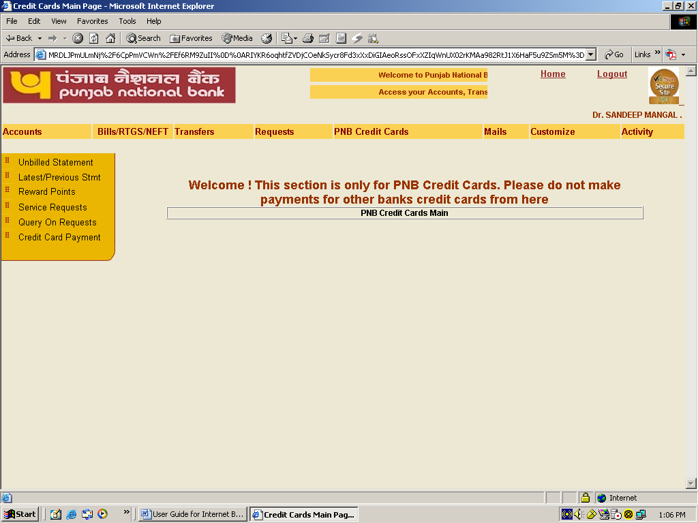

The following services have been provided to the users. Select and click the service for details.

- Linking of Credit Card
- Viewing and printing of unbilled statement
- Viewing and Printing of previous statements
- Viewing of reward points
- Submission of various service requests
  - Reporting of lost Card
  - Request for new ATM Pin
  - Request for change in credit card limit
  - Physical delivery of credit card statement
  - Damaged card Replacement
  - Delink a credit card
  - Linking a credit card
- Query on the requests submitted by the user
- Payment of dues of credit card
  - Register for Credit Card Payments
  - Make a new Payment
  - View Pending Payments
  - View Payments made

Linking of credit card

A user will have to get his credit card linked by submitting his online request. For linking his credit card he will click on the link of service requests in the screen. After linking of credit card with Internet banking account a user can use various services available on the site.
The user will fill in the details of his credit card and will press “submit” to submit his request for linking his credit card with his Internet banking a/c. The information marked with * is mandatory. The linking of the card will take place in maximum 48 hours depending on the submission of correct information by the user.
For going to previous menu “cancel” button is to be clicked.

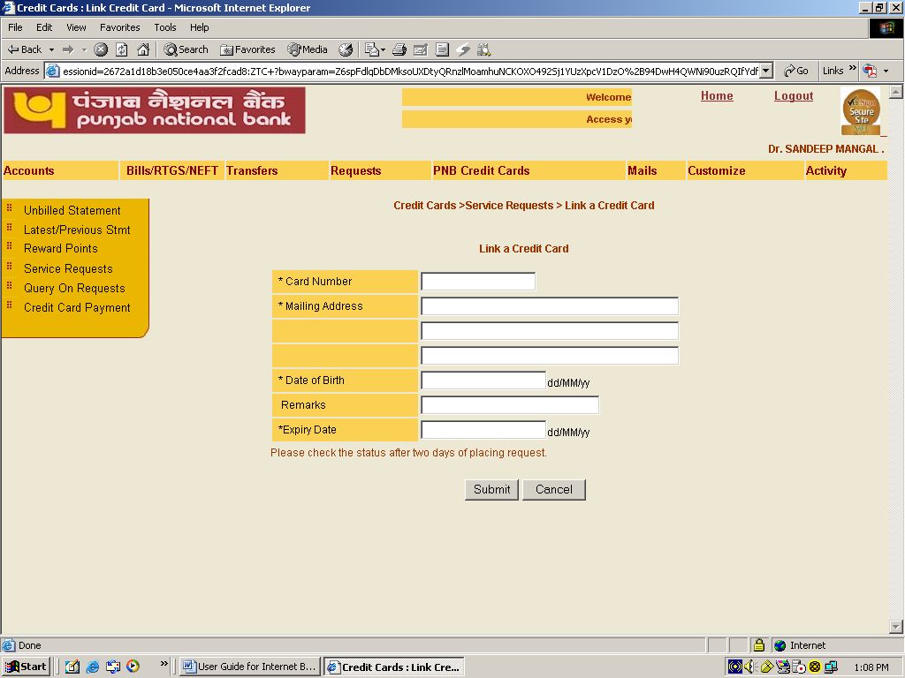

After pressing submit button the another screen asking user id and transaction password will appear. The user will fill up his user id and transaction password to complete the request.

For going to previous menu “cancel” button is to be clicked.

On successful submission of request the main service request screen will appear and a request reference number will be displayed on the top.

Viewing and printing of Unbilled statement

A user can view and print his current statement by clicking on the link of unbilled statement on main page. To view a current statement of the desired credit card, already linked to the Internet banking account, he will select the credit card number in the drop down list and will click “Go”. The statement of the selected credit card will be shown on the screen. By default the current statement of the first card in the drop down list will be shown. A user can also print and download his statement by clicking the links shown in the end of the statement. But in case there is no transaction in the account the printing of the statement will not be available.

For going to previous menu “Cancel” button is to be clicked.

Viewing and Printing of Latest/previous statements

A user can view and print his latest/previous statement by clicking on the link of latest/previous stmt on main page. To view a previous statement of the desired credit card, already linked to the Internet banking account, he will select the credit card and date of statement in the drop down lists and will press, “Fetch”. Statements of maximum three months can be viewed/ printed.

For going to previous menu “Cancel” button is to be clicked.

The selected statement of the selected credit card will be shown on the screen. A user can also print and download his statement by clicking the links shown in the end of the statement. But in case there is no transaction in the account the printing of the statement will not be available.

For going to previous menu “back” button is to be clicked.

Viewing of reward points

To view the reward points status on the linked credit cards a user will click on the link of reward points on the main page. He will select the card number from the drop down list for which he wants to view the reward points and click on “Go” button to view the reward points.

For going to previous menu “Cancel” button is to be clicked.

Submission of various service requests

Certain service requests are available to the user. He can open the page of service requests by clicking on the link of service requests on the main page.

The user can select any of the following services available to him by clicking on the desired request. While online requests status cannot be changed or cancelled by him, he can change the status of offline requests before their status is pending.

- Reporting of lost Card
- Request for new ATM Pin
- Request for change in credit card limit
- Physical delivery of credit card statement
- Damaged card Replacement
- Delink a credit card
- Linking a credit card

For going to previous menu “back” button is to be clicked.

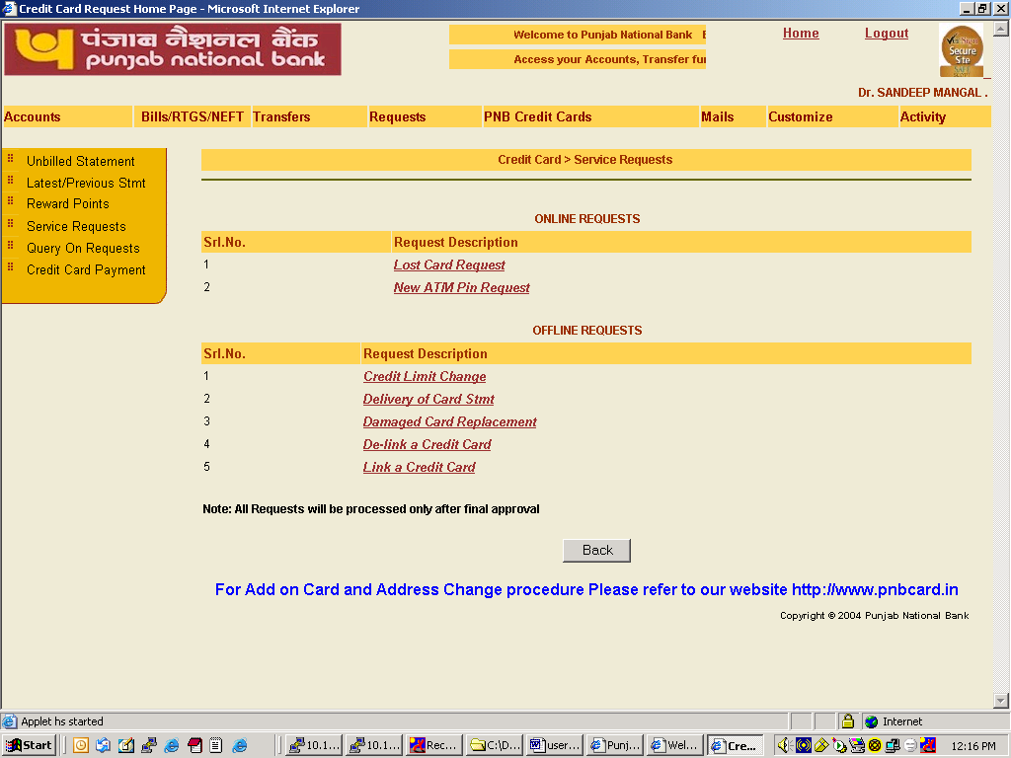

Damaged card Replacement

A user can select from service requests to submit his request for damaged card replacement. For this damaged card replacement link at the service requests page is to be clicked.

A damaged card request will be useful to a user when his card does not work due to damage of magnetic stripe, scratches, etc. The card will be reissued to the user on submission of this request. The user has to make certain that his existing card is not working. He should destroy his card by cutting the card in two or more pieces and removing the CVV numbers available on the card so as the ensure that these cannot be read by any one.

A small fee will be charged to the user for replacement of credit cards.

On making replacement of damaged card request another credit card will be issued to the user and will be sent on the address already registered.

The user can select a credit card linked to the Internet banking for replacement from the drop down list. After selecting a credit card and putting a remark for replacement he will click on “Submit” button to forward his request.

For going to previous menu “cancel” button is to be clicked.

After pressing submit button the another screen asking user id and transaction password will appear. The user will fill up his user id and transaction password to complete the request.

For going to previous menu “cancel” button is to be clicked.

On successful submission of request the main service request screen will appear and a request reference number will be displayed on the top.

Reporting of lost Card

A user can select from service requests to submit his request for reporting of lost card. For this reporting of lost card link at the service requests page is to be clicked.

On making reporting of lost card request the card will be blocked immediately to avoid any misuse.

The user can select a credit card linked to the Internet banking for reporting as lost card from the drop down list. After selecting a credit card and putting a remark for lost card he will click on “Submit” button to forward his request.

For going to previous menu “cancel” button is to be clicked.

After pressing submit button the another screen asking user id and transaction password will appear. The user will fill up his user id and transaction password to complete the request.

For going to previous menu “cancel” button is to be clicked.

On successful submission of request the main service request screen will appear and a request reference number will be displayed on the top.

Request for new ATM Pin

A user can select from service requests to submit his request for new ATM pin. For this Request for new ATM Pin link at the service requests page is to be clicked.

On making request for issue of new ATM pin a new pin will be sent to the user on the address already registered for credit card.

A small amount of fee will be charged to the user for new ATM pin issuance.

The user can select a credit card linked to the Internet banking for submission of request for new ATM pin from the drop down list. After selecting a credit card and putting a remark for new pin he will click on “Submit” button to forward his request.

For going to previous menu “cancel” button is to be clicked.

After pressing submit button the another screen asking user id and transaction password will appear. The user will fill up his user id and transaction password to complete the request.

For going to previous menu “cancel” button is to be clicked.

On successful submission of request the main service request screen will appear and a request reference number will be displayed on the top.

Request for change in credit card limit

A user can select from service requests to submit his request for change in Credit Card Limit. Fir this Credit Limit change link at the service requests page is to abe clicked.

The user can select a credit card linked to the internet banking for submission of request for change in credit card limit from the drop down list. After selecting a credit card and filling all the desired information he will click on “Submit” button to forward his request. Fields marked with * are mandatory.

For going to previous menu “cancel” button is to be clicked.
After pressing submit button the another screen asking user id and transaction password will appear. The user will fill up his user id and transaction password to complete the request.

For going to previous menu “cancel” button is to be clicked.

On successful submission of request the main service request screen will appear and a request reference number will be displayed on the top.

Physical delivery of credit card statement

A user can select from service requests to submit his request for delivery of a credit card statement for the desired period.

For this Delivery of credit Card Stmt. link at the service requests page is to be clicked.

The user is required to select the following:
- Credit card linked to the internet banking for which physical statement is required
- Statement month
- Statement Year
- Delivery mode

for submission of request for delivery of credit card statement. He is also required to fill the change in credit card limit from the drop down list. After selecting a credit card and filling all the desired information he will click on “Submit” button to forward his request. Fields marked with * are mandatory.

The delivery of credit card statement of older than three months will attract nominal fees.

For going to previous menu “cancel” button is to be clicked.

After pressing submit button the another screen asking user id and transaction password will appear. The user will fill up his user id and transaction password to complete the request.

For going to previous menu “cancel” button is to be clicked.

On successful submission of request the main service request screen will appear and a request reference number will be displayed on the top.

Delink a credit card

A user can select from service requests to delink a credit card, which is linked to his internet banking account.

For this Delink a credit Card link at the service requests page is to be clicked.

The user will select a card, which is to be delinked, from the drop down and fill remarks and will click on “Submit” button to forward his request.

For going to previous menu “cancel” button is to be clicked.

After pressing submit button the another screen asking user id and transaction password will appear. The user will fill up his user id and transaction password to complete the request.

For going to previous menu “cancel” button is to be clicked.

On successful submission of request the main service request screen will appear and a request reference number will be displayed on the top.

Query on the requests submitted by the user

A user can view the status of the requests submitted by him by clicking Query on Requests link available on the main page.
A user can select a request from the drop down list for which query is to be made. He may fill from and to date for which the query is to be fetched. He may also retrieve a request by giving the request reference number. A user can select status of the request for which query is desired. In case status is selected “ALL”, all requests irrespective of status will be displayed.

To retrieve the desired request “Retrieve” button is required to be clicked.

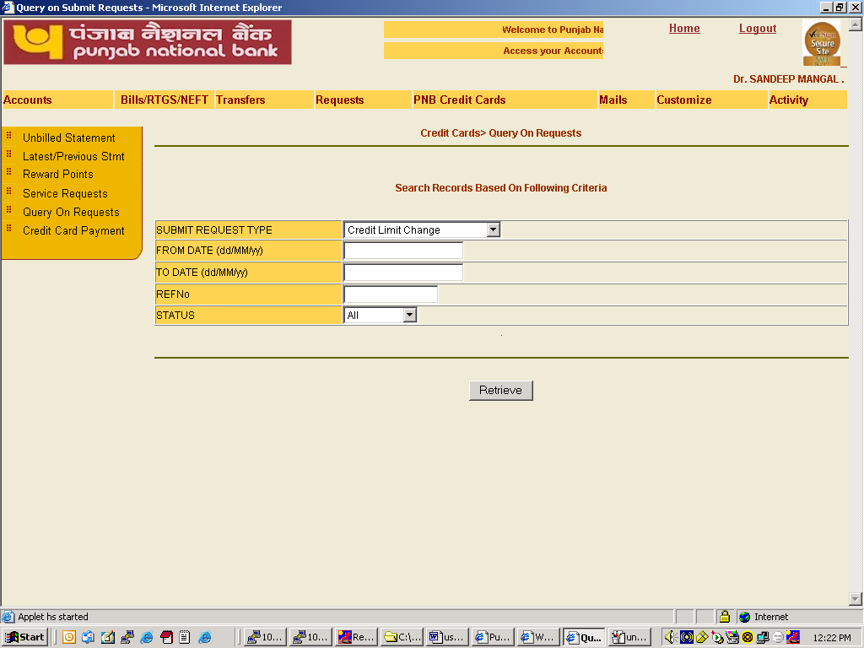
At a page only five records will be shown. To view next five records “next” button is required to be clicked. To view previous five records “previous” button is to be clicked. To go back to previous screen “Cancel” button is to be clicked.

Payment of dues of credit card

A facility of making the dues of credit cards has also been provided to the users. For opening the credit card payments menu the concerned link is to be clicked on the main page.
The following four options are available to a user:

- Register for Credit Card Payments
- Make a new Payment
- View Pending Payments
- View Payments made

Register for Credit Card Payments

For registering a credit card for payment the link of “Register for Credit Card Payments” is to be clicked.

The following screen will appear for registering a credit card for payment. A user will fill the cardholder name and card number for which the registration of payment is desired. After filling these details he will click “Add” button.

To go to previous screen “cancel” button is to be pressed.
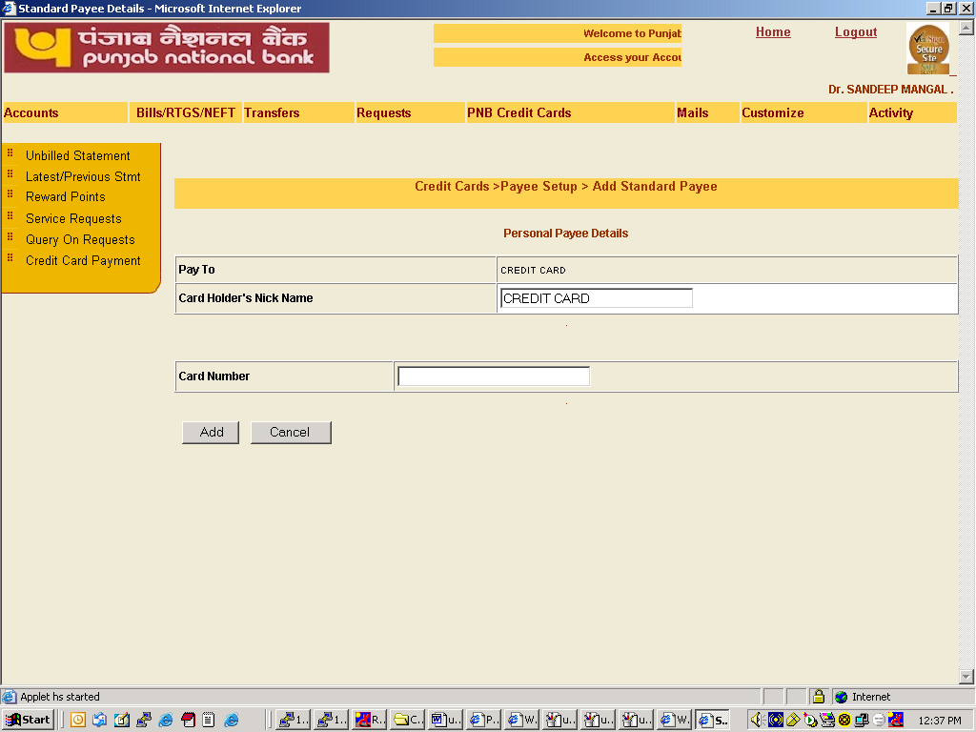

On successful submission of request a new screen will appear and the credit card registered for payment will be shown in the screen. A reference id number will also be reflected on the of the screen.

In case a credit card is already registered for payment it will be shown in the screen as shown above. The detail of already registered credit cards can be viewed by clicking the cardholder’s nickname.

In case a user desires to delete the card number from the list of registered cards for payment, he is required to select “Delete this Personal Payee from my personal list” and click on “update” button.

Make a new Payment

In case he intends to make payment of a credit card the link of “Make a new Payment” is required to be clicked on the payment of credit card page. This clicking will bring the following screen.

The user can select either own card or other card, which have been registered for payment by clicking on the appropriate link.

To go to previous page “Previous” button is to be clicked.

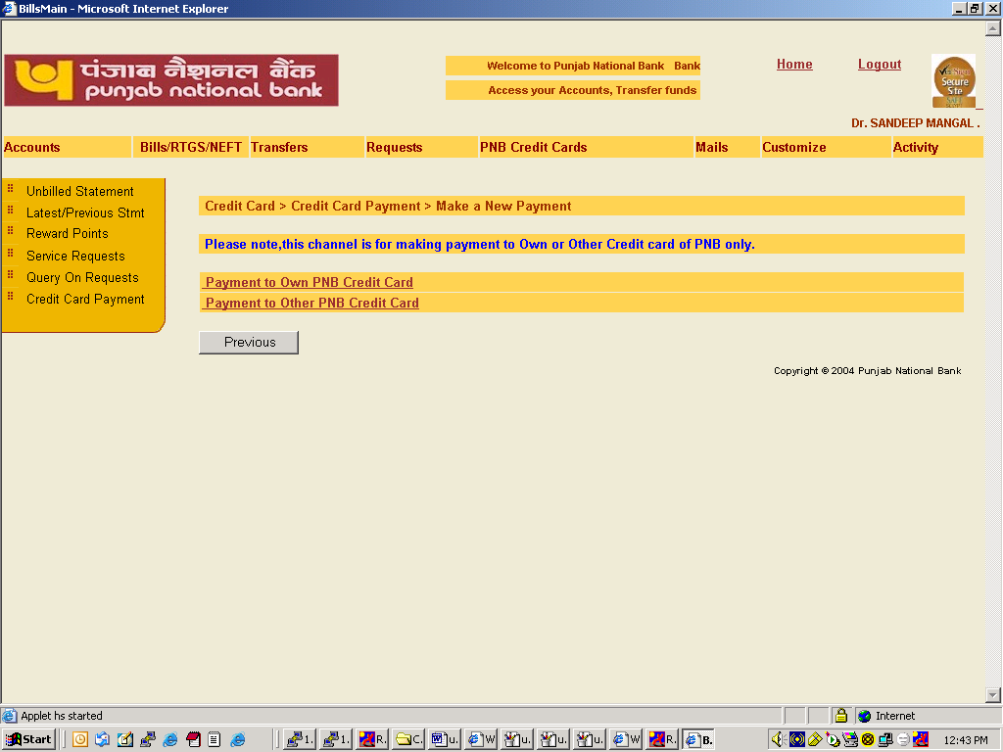

In case a user selects to make payment of own card a new screen will appear. He is required to select a card from own registered cards from the drop down list and click “fetch” button to bring the details of payment.

He may click on “previous” button to go to previous screen.

This screen will show a user the minimum amount due and total amount due on the selected credit card. The user may fill the amount which he intends to pay. The user is required to select an account from the drop down list from which the payment will be made. He may also enter any payment remarks if he intends so.

The user may make hot payment or may instruct for a date of payment. In case of hot payment his account will be debited immediately. In case he opts for payment on a particular date his account will be debited on the specified date.

The payments made by him will be reflected in his credit card account on the next day.
He may click on “previous” button to go to previous screen.

After pressing submit button the another screen asking user id and transaction password will appear. The user will fill up his user id and transaction password to complete the request.

For going to previous menu “cancel” button is to be clicked.

On successful payment a payment confirmation number will be given to the user.

In case a user selects to make payment of other card a new screen will appear. He is required to select a card from the registered cards from the drop down list. The user may fill the amount, which he intends to pay. The user is required to select an account from the drop down list from which the payment will be made. He may also enter any payment remarks if he intends so.

The user may make hot payment or may instruct for a date of payment. In case of hot payment his account will be debited immediately. In case he opts for payment on a particular date his account will be debited on the specified date.

The payments made by him will be reflected in his credit card account on the next day.

He may click on “previous” button to go to previous screen

After pressing submit button the another screen asking user id and transaction password will appear. The user will fill up his user id and transaction password to complete the request.

For going to previous menu “cancel” button is to be clicked.

On successful payment a payment confirmation number will be given to the user.

View Pending Payments

A user can view the pending payments for which he has already submitted requests. In case any payment is in pending status that will be shown.

To view pending payments a user will select “View Pending Payments” in the credit card payment page.

A user will fill nickname and select a credit card from the drop down list. He will click on “select” button to view the status of pending payments. The records will be shown only when payments are pending otherwise a message will be flashed on the of the screen as under:

“No records fetched”

View Payments made

A user can view the details of payments made. To view payments made a user will select “View Payments made” in the credit card payment page.

To view a payment made a user will select a credit card number from the drop down list and fill the query details. He may also select success or failed payments from the drop down to view. To view the list of payments made “retrieve” button is required to be clicked.

To go to previous screen “previous” button is to be clicked.

The following screen will be displayed.

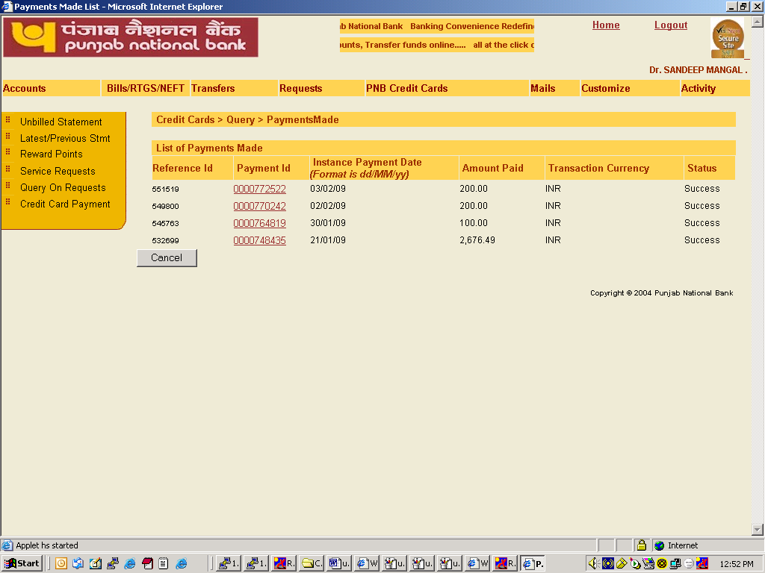

The screen will reflect five payments on a page. “next” button is required to be clicked to view next five payments. To go to previous five payments “Prev” button is required to be clicked.

To go to previous screen “cancel” button is required to be clicked.

In case a user wants to view the details of a particular payment he is required to click on the payment id for which the details have been desired.

