Map from: Radon Potential in the Lake Tahoe Area, California
CGS Special Report 221, 2009

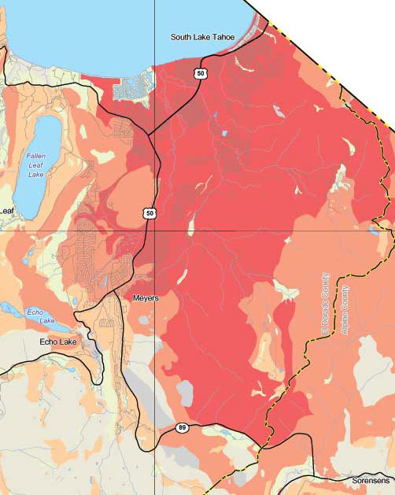

Index Indoor Radon Potential
Red Very High
Orange High
Tan Moderate
Yellow Low
Gray Unknown

