Leif Svalgaard's Early Computer Experience

From: http://web.syr.edu/~pbhansen/html/biography.html

Adapted from the IEEE brochure describing Per Brinch Hansen’s 2002 Computer Pioneer Award

Per Brinch Hansen is one of a handful of computer pioneers who was responsible for advancing both operating systems development and concurrent programming from ad hoc techniques to systematic engineering disciplines. His work illustrates a relentless search for simplicity exemplified by the RC 4000 multiprogramming system, the monitor concept, and the programming language Concurrent Pascal. His work has influenced most operating systems and concurrent programming languages developed over the last twenty-five years.

P. Brinch Hansen, Programmøren som hvalp. In Niels Ivar Bech: en epoke i edbudviklingen i Danmark, P. Sveistrup, P. Naur, H.B. Hansen, and C. Gram, Eds., (in Danish), Data, Copenhagen, Denmark, (1976), 65{68. English translation by Brinch Hansen:

[...] Our programming group consisted of Peter Kraft, Charles Simonyi, and me. Peter was an experienced programmer, who had learned his craft during the Gier-Algol project. Charles was a long-haired teenager, a refugee from Hungary who was fascinated by everything in the western world. Later he went to the United States and worked for Xerox in California. [Leif's comment: Charles went on to join Microsoft. He wrote "Microsoft Word"]
[...] Our group was also joined by a student, Leif Svalgaard [...]. Leif liked to show off. Once he told us that he had a new theory of the magnetic fields of the sun and earth. That made us smile a bit. Later, I met Leif in the United States. He was then working at Stanford University and his theory was world-famous.
[...] I have lectured at most of the leading universities and research centers in the United States. But only at Carnegie-Mellon University and Xerox Research Center have I found programming groups that measured up to Regnecentralen's.

-----------------------------------------------------

http://en.wikipedia.org/wiki/RC_4000_Multiprogramming_System
The RC 4000 Multiprogramming System was an operating system developed for the RC 4000 minicomputer in 1969. It is historically notable for being the first attempt to break down an operating system into a group of interacting programs communicating via a message passing kernel. Although RC 4000 itself was not very successful it was nevertheless extremely influential, sparking the microkernel concept that dominated operating system research through the 1970s and 80s. The system is also known as Monitor and, somewhat confusingly, simply RC 4000 depending on the reference. [...]For clarity, this article will use the term Monitor. Monitor was created largely by one programmer, Per Brinch Hansen, who worked at Regnecentralen where the RC 4000 was being designed. [Leif's comment: this is not quite correct, it was written by two programmers, Per and myself, c.f. Per's paper cited below]

http://brinch-hansen.net/papers/1970a.pdf
P. Brinch Hansen, The nucleus of a multiprogramming system, Communications of the ACM 13, 4 (April 1970), 238-242.
The design philosophy was developed by Joern Jensen, Soeren Lauesen, and the author. Leif Svalgaard participated in the implementation and testing of the final product.

-----------------------------------------------------------------

Weather map drawn by RC4000 computer at Danish Meteorological Institute ca. 1971. I developed the first ever program (ca. 1965) to do this with the quality to compete with hand-drawn maps. See: http://gier.dk/site_dk/rc/rc4000/dmi/edbafdelingen.shtml
(Text in Danish) I efteråret 1965 viste stud. mag. Leif Svalgård, at det var muligt på en tegnemaskine, tilsluttet som ydre enhed til en GIER-datamaskine, at omsætte de synoptiske observationer i kodet form til indprikkede stationer på et vejrkort.

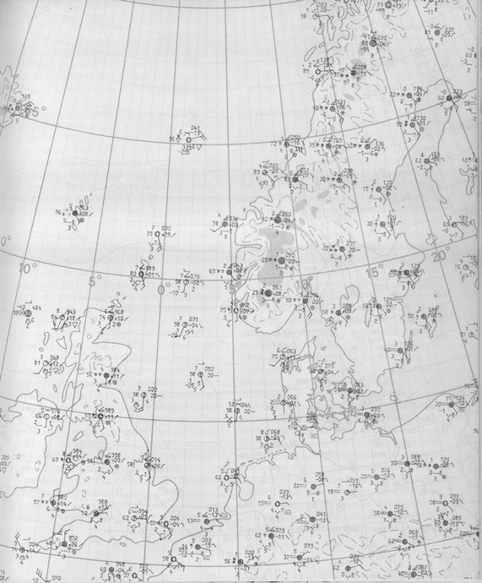

---------------------------------------------------------------------

From letters in my possession:

1) The University of Texas at Austin.

To Whom it May Concern:
I am writing this letter on behalf of Leif Svalgaard to comment on his computer science experience [...] Mr. Svalgaard was involved in the development and implementation of the RC4000 computer operating system.

As author of the computer science textbook 'Operating System Concepts' [...] and as a teacher of operating system courses for over fifteen years.I am extremely familiar with the historical development of operating systems and with the kind of technical expertise required to develop and implement an operating system.

The RC4000 system was an important and influential early effort in the operating system field. It was notable primarily for its innovative design concepts. [...] Mr. Svalgaard's involvement with the RC4000 system has been documented in Per Brinch-Hansen's classic book 'Operating System Principles' [...] , 1973.

The specification and design of an operating system is an extremely create and demanding task; the successful implementation of an operating system requires a high level of training and skill in software engineering. As co-developer (with Per Brinch-Hansen) of the historically important RC4000 operating system, Mr. Svalgaard can claim a depth of experience and documented expertise in the computer science field [...]. This work can be considered as equivalent to advanced standing graduate work, such as research leading to a doctoral dissertation, or as equivalent to work performed in a post-graduate position.
[...] Signed Avi Silberschatz,
Professor in C.S.

2) Center for Space Space and Astrophysics, Stanford University

To Whom it May Concern:

This letter is to confirm that Leif Svalgaard worked with me at Stanford University from about 1972 through 1978. During this time Leif worked both as a computer software specialist and as a space physics scientist. He has superb skills in operating systems design, implementation, and modification. He designed and implemented a computer simulator system which allowed the use of existing system software on a new
machine. He participated in the design and implementation of the operating system and [real-time] control software for the Wilcox Solar Observatory (then [the] Stanford Solar Observatory) telescope. He also developed a significant amount of end-user solar physics code which was used by the Solar Observatory research group as well as by himself.
[...]
(signed)
Phillip H. Scherrer
Professor, Applied Physics and Center for Space Science and Astrophysics

